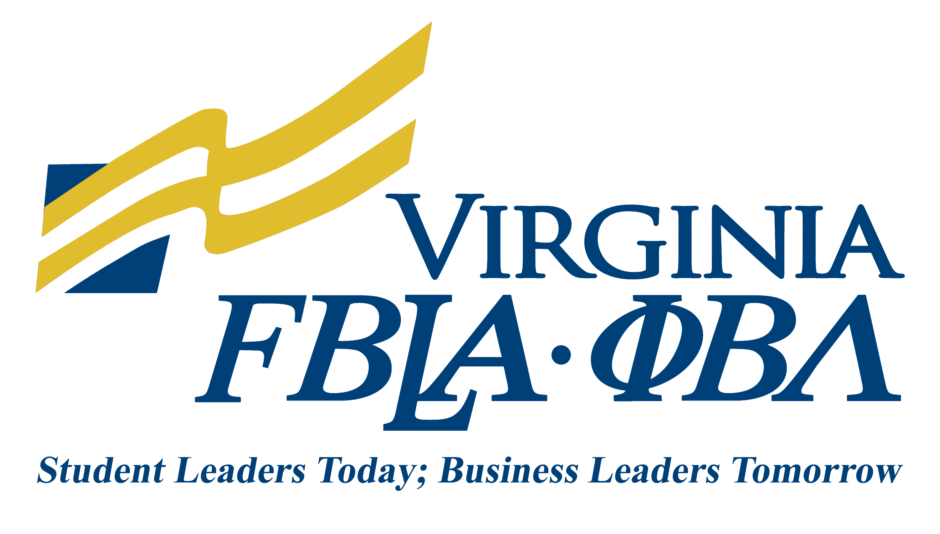

L. Marguerite Crumly Scholarships Regional

Frank manning Peele Scholarships State Conference

Interview Rating Sheet

Evaluation Item | Not Demonstrated | Does Not Meet Expectations | Meets Expectations | Exceeds Expectations | Points Earned

SCHOLASTIC/ORGANIZATIONAL QUALIFICATIONS
Scholastic Aptitude/Achievement | 0 | 1-8 | 9-17 | 18-25
FBLA Involvement | 0 | 1-8 | 9-17 | 18-25
INTERVIEW
Professional appearance (grooming and appropriate attire); Poise, maturity, and attitude; Communication skills | 0 | 1-5 | 6-10 | 11-15
Evidence of career planning; Evidence of community involvement; goals and aspirations | 0 | 1-5 | 6-10 | 11-15
APPLICATION MATERIALS
Clear and concise presentation of facts; Neatness; Completeness; Correct grammar, punctuation, and spelling | 0 | 1-6 | 7-13 | 14-20
PENALTY POINTS: Deduct up to 10 points for failure to fully follow the guidelines.
TOTAL POINTS |  |  |  |  | /100 max

Name:
School:

